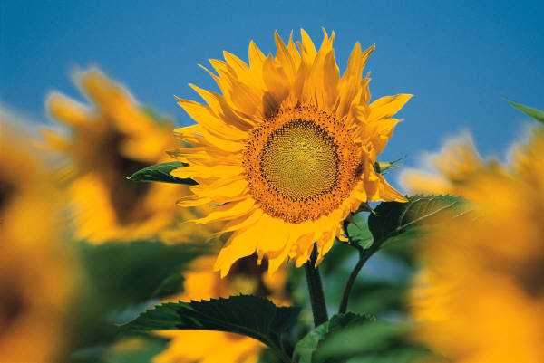

**Thinking of You Flowers!**

**from St Saviour’s**

**Flowers**

**JULY**

**To**

**DECEMBER**

**2025**

**July 2025** Jul 6 Julie Bulpitt

Jul 13 Pat Chalker

Jul 20 Sue Brock

Jul 27 Suzie Toynton

**August** Aug 3 Gill Osmond

Aug 10 Josie Le Cras

Aug 17 Mary Pease

Aug 24 Nicola Robinson

Aug 31 Lena Chesney

**September** Sep 7 Heather Mauger

Sep 14 Bridget Carey

Sep 21 Alison Foley

Sep 28 Laura Weeks

**October** Oct 5 Georgia Williams

Oct 12 Mary Hallam

Oct 19 Josie Le Cras

Oct 26 Caroline Allaby

**November** Nov 2 Heather Mauger

Nov 9 Vicky Archard

Nov 16 Margaret Macdonald

Nov 23 Helen Bradshaw

Nov 30 Sarah-Jane Allen

**December** Dec 7 Gemma Lewin

Dec 14 Joanne Phillips

Dec 21 Millie Le Poidevin

*- Please swap your week if you need to -*

*Ring Sarah-Jane (07781-400686) with any questions- thank you!*